Socket io:

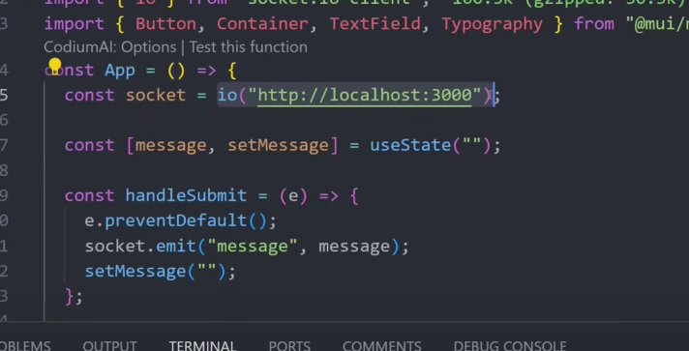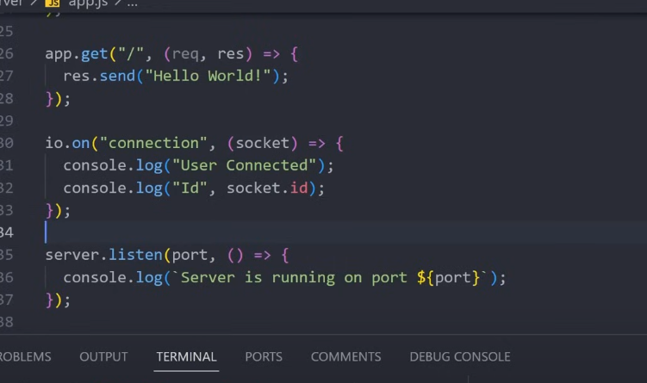

Isme problem ye hai ki ki jab value of message change ho raha hai as when we send message then component rerender becaz of space change and thus becaz of this ,due ti rerender socket io make new connection again with backend

Thus we will use useMemo for this socket io

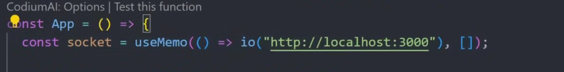

Ab is case socket io tabhi re-connection builtin karega jab vo refresh hoga ,na ki rerender ho,basically mount hone ke time pe sirf change karega

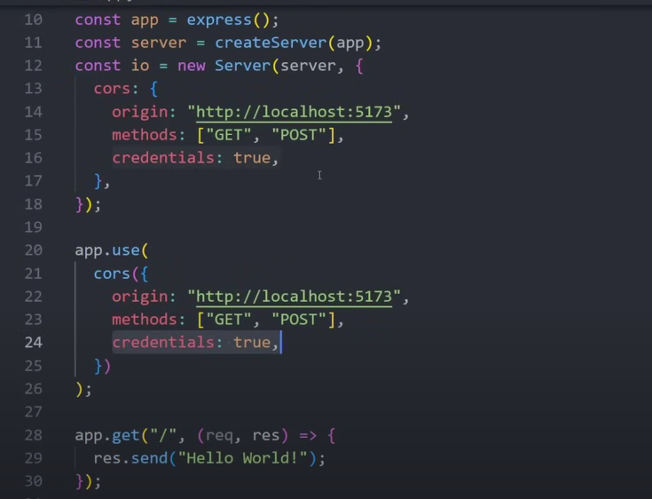

Cookie parser in socket io

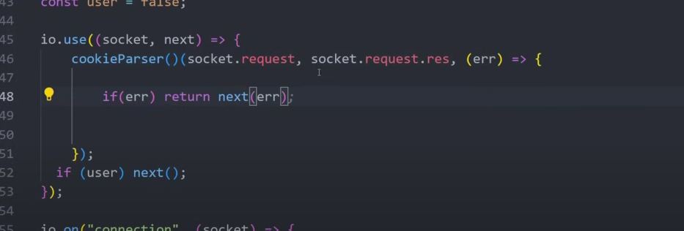

Credential true laga lo taki hum cookies bhej sake

